**Supplementary Information**

*********

Multiscale modeling allows to study the different modes of cancer cell invasion

Marco Ruscone1,2,3,*, Arnau Montagud5, Philippe Chavrier6, Olivier Destaing7, Andrei Zinovyev1,2,3, Emmanuel Barillot1,2,3, Vincent Noel1,2,3,↟ and Laurence Calzone1,2,3,*,↟

**Outline**

1. Connecting the agent-based model to the Boolean Model
2. Cell Cycle model in PhysiBoSS
3. Logical formulae of the intracellular model
4. List of parameters of the model
5. Sensitivity analysis on model parameters

### Connecting the agent-based model to the Boolean Model

Below the description of the workflow linking the outputs of the agent-based model (ABM) model to the Boolean model (BM).

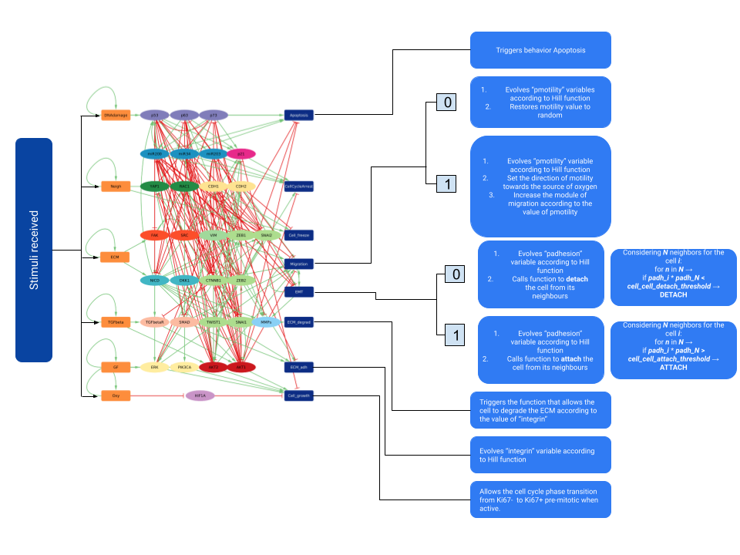

### 

### Cell Cycle model in PhysiBoSS

PhysiBoSS already provides the user with different options for cell cycle description.

For this study, we chose the model of the cell cycle based on Ki67 (Advanced Ki67 CellCycle model).

This cell cycle is composed of 3 phases and 3 transitions. Each cell starts in interphase (referred to as standard phase in PhysiCell) Ki67-. Once the *Cell_growth* output node is activated, it triggers the transition to the next phase, Ki67+ pre-mitotic.

The cell then starts growing and once it reaches a certain threshold, it divides into two daughter cells that inherit the phenotype of the mother cell. Both daughter cells stay in Ki67+ post-mitotic phase and switch again to an early cell cycle phase Ki67- at a default transition rate provided by PhysiCell.

### Logical formulae of the intracellular model

The notation for the logical connectors is:

& for AND

| for OR

! for NOT

| **Variable** | **Logical rule** |
| --- | --- |
| HIF1A | !Oxy |
| FAK | (ECM | (SRC)) & !p53 |
| YAP1 | ((!AKT1 | ! AKT2) & SRC) |
| RAC1 | ( SRC | FAK) & !(AKT1 | AKT2 ) |
| PIK3CA | (GF | RAC1) |
| MMPs | ( MMPs & (((NICD & SMAD)| RAC1) & !p73) ) | p63 |
| SRC | FAK |
| NICD | (!p73 & !p53 & !p63 & !miR34 & !miR200 & (ECM | FAK)) |
| CTNNB1 | (!DKK1 & !p53 & !AKT1 & !p63 & !miR34 & !miR200 & !CDH1 & CDH2 & !SRC) |
| DKK1 | (!NICD & CTNNB1) | (NICD) |
| AKT2 | TWIST1 & (TGFbeta | GF | CDH2) & !(miR203 | miR34 | p53) |
| ZEB1 | ((TWIST1 & SNAI1) | CTNNB1 | SNAI2 | NICD) & ! miR200 |
| SNAI1 | (NICD | TWIST1) & ! miR203 & ! miR34 & ! p53 & ! CTNNB1 |
| ZEB2 | (SNAI1 | (SNAI2 & TWIST1) | NICD) & ! miR200 & ! miR203 |
| p73 | (!AKT2 & !ZEB1 & !p53 & !AKT1 & DNAdamage & !YAP1) |
| p53 | (DNAdamage | CTNNB1 | NICD | miR34) & ! SNAI2 & ! p73 & ! AKT1 & ! AKT2 |
| AKT1 | (CTNNB1 & (NICD | TGFbetaR | GF | CDH2) & ! p53 & ! miR34 & ! CDH1) |
| p63 | (!NICD & !AKT2 & !p53 & !AKT1 & DNAdamage & !miR203) |
| miR34 | !(SNAI1 | ZEB1 | ZEB2) & (p53 | p73) & AKT2 & ! p63 & ! AKT1 |
| SNAI2 | (TWIST1 | CTNNB1 | NICD) & ! miR200 & ! p53 & ! miR203 |
| miR200 | (p63 | p53 | p73) & !(AKT2 | SNAI1 | SNAI2 | ZEB1 | ZEB2) |
| TWIST1 | CTNNB1 | NICD | SNAI1 |
| CDH1 | (!AKT2 & !ZEB1 & !ZEB2 & !SNAI1 & !SNAI2 & !TWIST1 & !SRC & Neigh) |
| CDH2 | (TWIST1 | SRC) |
| TGFbetaR | (NICD & !CTNNB1 & TGFbeta) |
| miR203 | (!ZEB1 & !ZEB2 & !SNAI1 & p53) |
| ERK | ((SMAD | CDH2 | GF | NICD) & !AKT1) |
| SMAD | (!miR200 | !miR203) & (TGFbetaR | YAP1) |
| p21 | ((SMAD & NICD) | p63 | p53 | p73 | AKT2) & !(AKT1 | ERK) |
| VIM | CTNNB1 | ZEB2 | SRC |
| EMT | (!CDH1 & CDH2) | EMT & (!CDH1 & CDH2) |
| Migration | (AKT2 & !AKT1 & !miR200 & ERK & VIM & EMT & ((CDH2 & SMAD) | (CTNNB1)) & !p63) |
| Apoptosis | (p53 | p63 | p73 | miR200 | miR34) & ! ZEB2 & ! AKT1 & ! ERK |
| ECM_adh | (NICD & !CDH1 & SMAD) | RAC1 |
| ECM_degrad | MMPs |
| CellCycleArrest | (miR203 | miR200 | miR34 | ZEB2 | p21) & !AKT1 |
| Cell_freeze | (Neigh & !CDH2 & CDH1) |
| Cell_growth | ((ERK & !p21) | (AKT1 & AKT2 & PIK3CA)) & !HIF1A |

### List of parameters of the model

Here we report a brief list of the main parameters of the simulation with a short description.

| **Parameter** | **Description** | **Value** |
| --- | --- | --- |
| Domain | 3D / 2D space domain | 600x600(x600)μm |
| ∆space | voxel’s unit measure | 10 μm |
|  | | |
| ***Cell-substrates interaction parameters*** | | |
| ecm_adhesion_min | set the min adhesion between cells and ECM | 1 |
| ecm_adhesion_max | set the max adhesion between cells and ECM | 2 |
| cell_ecm_repulsion | set the value of ECM repulsion | 15μm/min |
|  | | |
| ***Cell parameters*** | | |
| max_interaction_factor | set the max distance of interaction | 1.3μm |
| homotypic_adhesion_min | set the min adhesion between cells of the same type | 0.4 |
| homotypic_adhesion_max | set the max adhesion between cells of the same type | 0.8 |
|  | | |
| ***Threshold parameters*** | | |
| contact_ECM_threshold | change the threshold needed to trigger ECM interaction | 0.05 |
| contact_TGFβ_threshold | change the threshold needed to trigger TGFβ interaction | 0.02 |
| contact_cell_cell_threshold | change the threshold needed to trigger Neigh node | 0.3 |
| cell_junctions_attach_threshold | change the threshold needed to attach cells in cluster with cell junction | 0.05 |
| cell_junctions_detach_threshold | change the threshold needed to detach cells in cluster with cell junction | 0.03 |
|  | | |
| ***Motility parameters*** | | |
| migration_bias | change value of migration bias for cells with migration node active | 0.85 |
| migration_speed | change value of migration speed for cells with migration node active | 0.5μm/min |
| motility_amplitude_min | change the min value of motility amplitude | 0.1 |
| motility_amplitude_max | change the max value of motility amplitude | 0.8 |
|  | | |
| ***Substrates parameters*** | | |
| config_radius | change the initial radius of the tumor | 100μm |
| TGFβ_radius | change radius of the TGFβ substrate | 90μm |
| densityβ | change initial density of the TGFβ substrate | 0.4 |
| density_ECM | change initial density of the ECM substrate | 0.5 |
| ECM_degradation | change the amount of ECM degraded by the cells | 0.05 |
| ECM_TGFβ_ratio | change the amount of TGFβ degraded by the cells | 0.002 |
| TGFβ_degradation | change the threshold needed to start sensing TGFbeta inside a voxel with ECM | 0.75 |

### Sensitivity analysis on model parameters

We run a sensitivity analysis on the parameters of the ABM model that are linked to the BM. The goal is to measure how each parameter affects the amount of cells that migrate as single cells or as clusters. We select 7 parameters among the ones shown in the previous section. For each parameter, we choose a range of values to test. For each value we did 50 runs and took the mean value and the squared mean error to see how the stochasticity of the simulation affected the results.

Each parameter has been tested independently. To limit the computational cost, we performed the sensitivity analysis on one parameter at a time.

The simulations took a total of almost 90 hours on a High Performance Computer.

To measure the amount of single and collective migration, we printed on a csv file the amount of interactive neighbors for each cell at each time step of the simulation. To separate the clusters and the single cells, we took advantage of a representation of the simulation as a network, using NetworkX to read the csv. Finally we counted the disconnected components of the resulting network, excluding the strongly connected component, which represents the core of the tumor.

The parameters are the following:

| **Parameters** | **Range** |
| --- | --- |
| *cell_ecm_repulsion*  regulates the amount of repulsion between cell and ECM | 5 < **15** < 40 |
| *cell_attachment_threshold*  changes the activation threshold needed to attach cells in cluster with cell junction | 0.001 < **0.05** < 1 |
| *cell_detachment_threshold*  change the activation threshold needed to detach cells in cluster with cell junction | 0.001 < **0.03** < 1 |
| *cell_cell_contact_threshold*  changes the activation threshold of the value *cell_contact* needed to trigger Neigh node | 0.01 < **0.3** < 3.5 |
| *cell_ecm_contact_threshold*  changes the activation threshold of the value *ecm_contact* needed to trigger ECM node | 0.001 < **0.05** < 1 |
| *migration_bias*  changes the value of migration bias for cells with *Migration* node active | 0.5 < **0.85** < 1 |
| *migration_speed*  changes the value of migration speed for cells with *Migration* node active | 0.3 < **0.7** < 1 |

The graphs below show the proportions of cells that are found as single cells (blue) or in clusters (orange) for various values of the parameters. Some results and interpretations are discussed in the main text.

* *cell_attachment_threshold*

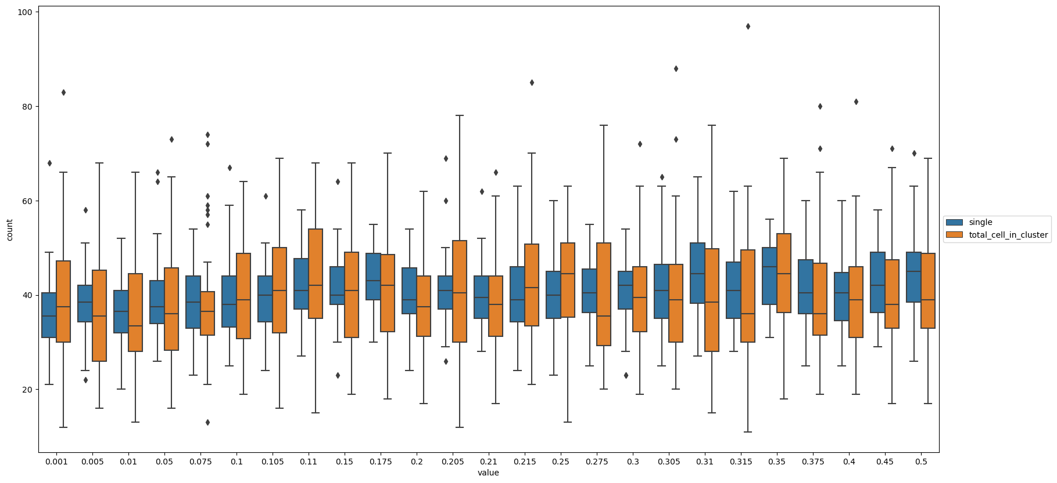

From the analysis, this parameter seems robust and shows a moderate change in the amount of single vs. collective migrating cells.

* *cell_detachment_threshold*

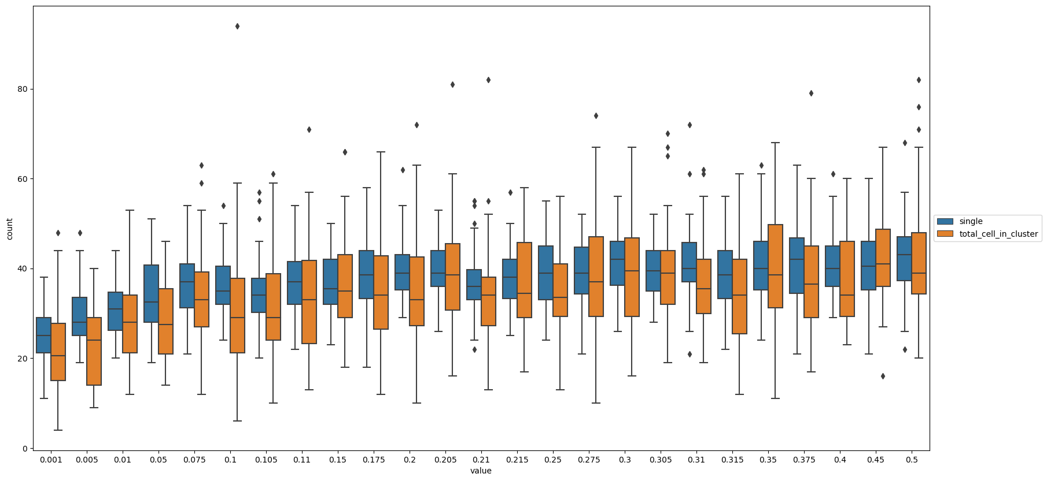

From the analysis, this parameter seems robust for values higher than 0.05 and it shows no changes in the rate between single and collective migrating cells. For values lower than 0.05, the amount of single vs. collective cells tends to diminish.

* *migration_bias*

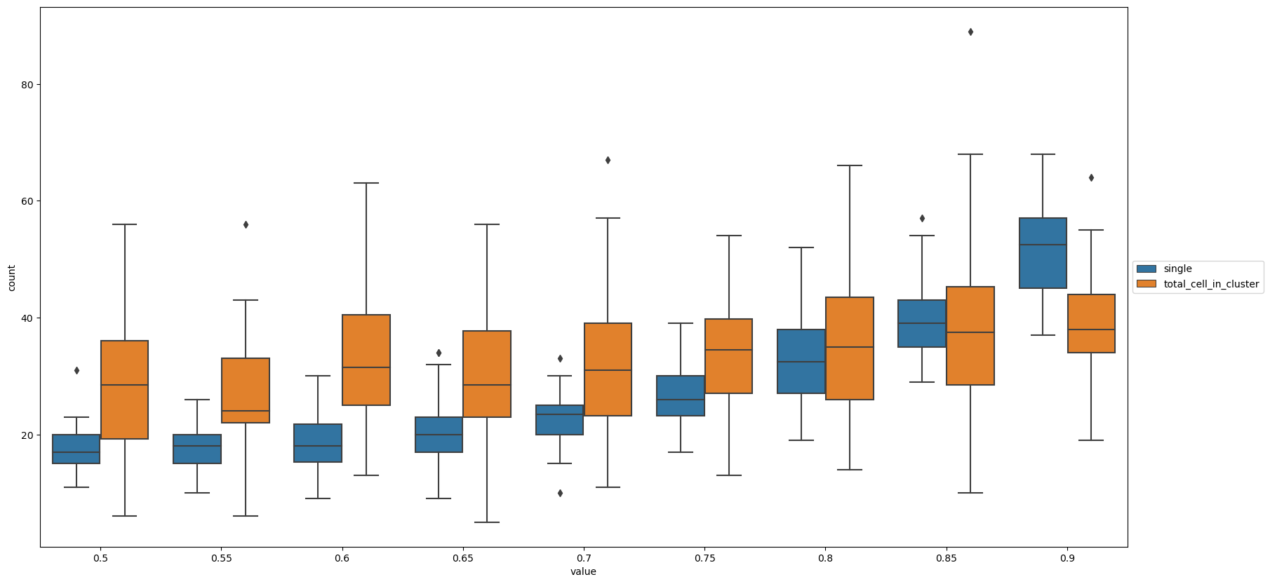

From the analysis, this parameter heavily influences the amount of single and collective migration: for values minor than 0.85 the amount of cells migrating in clusters is higher than the single cells. For higher values, the number of single cells exponentially increases.

* *migration_speed*

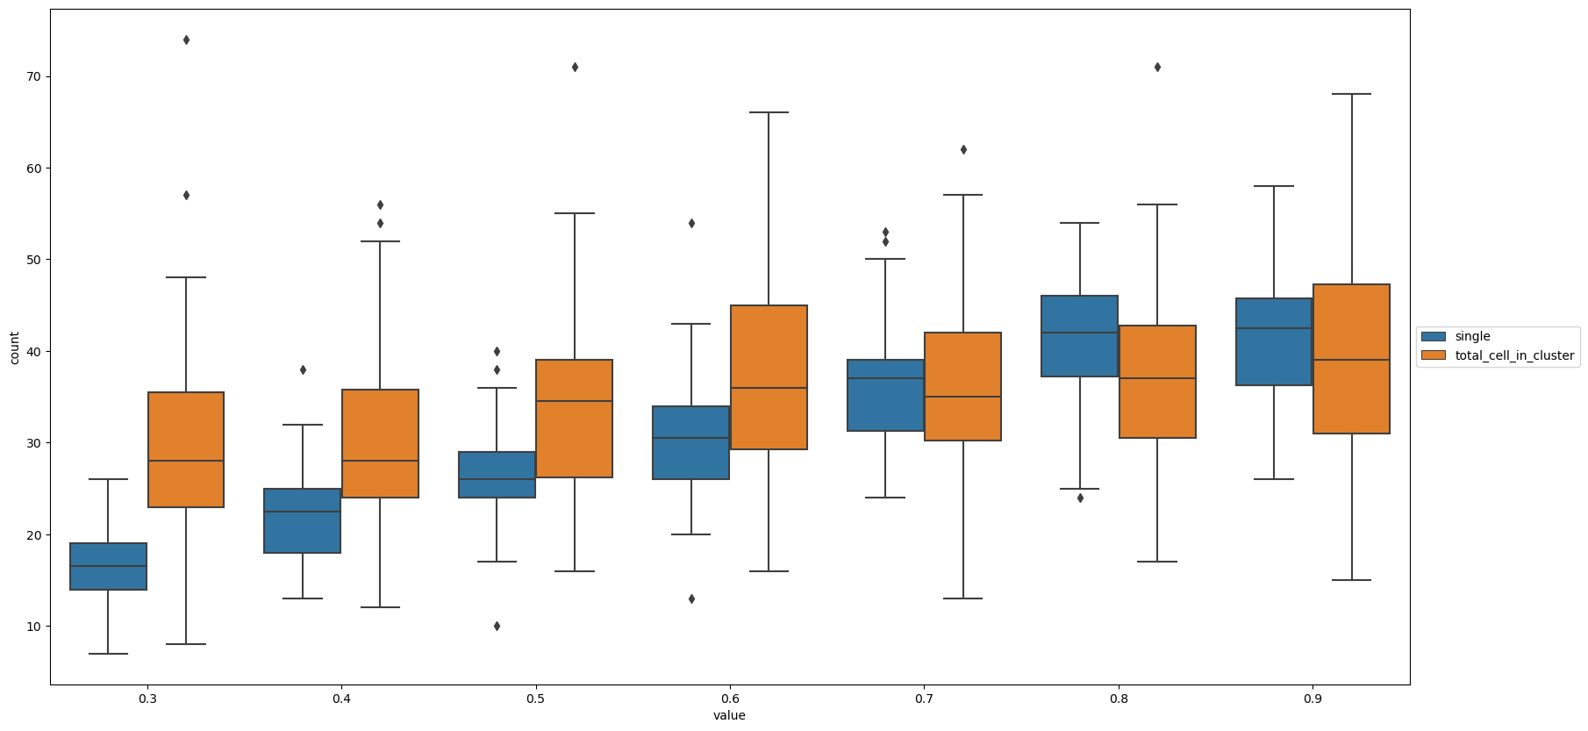

From the analysis, this parameter heavily influences the amount of single and collective migration: for values minor than 0.7 the amount of cells migrating in clusters is higher than the single cells. For higher values, the number of single cells linearly increases.

* *cell_ecm_contact_threshold*

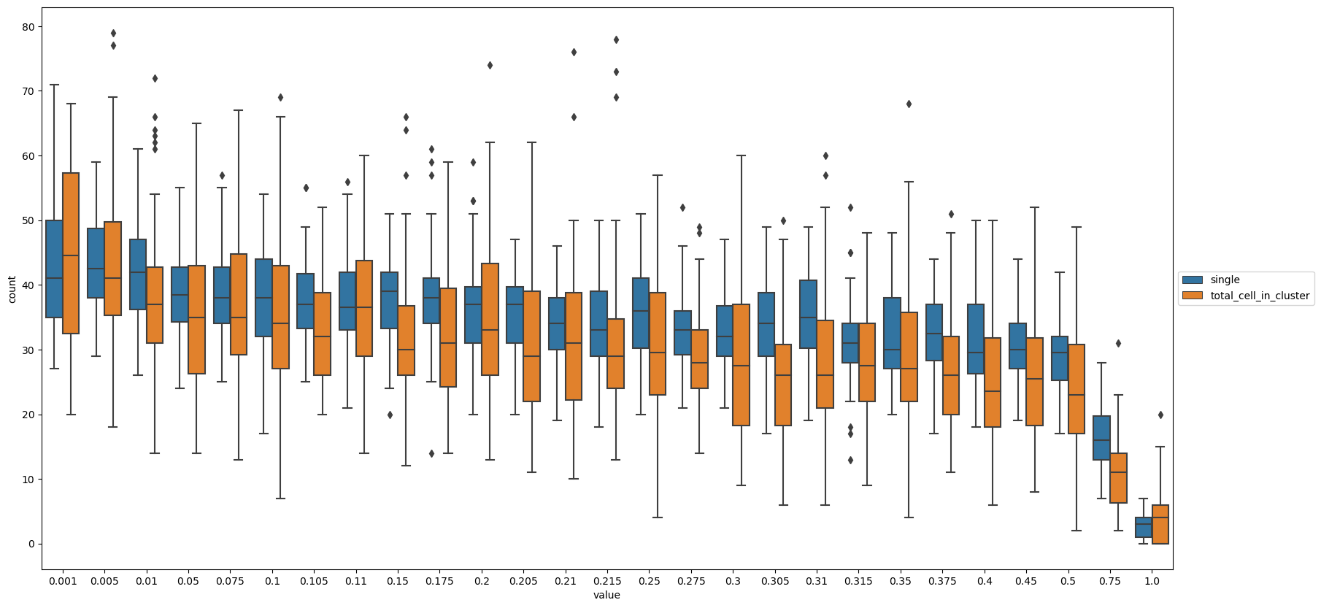

From the analysis, this parameter seems to influence the amount of single and collective migration: the rate between single and collective migrating cells seems to be constant, decreasing slightly up to 0.5, after that it rapidly decreases.

* *cell_cell_contact_threshold*

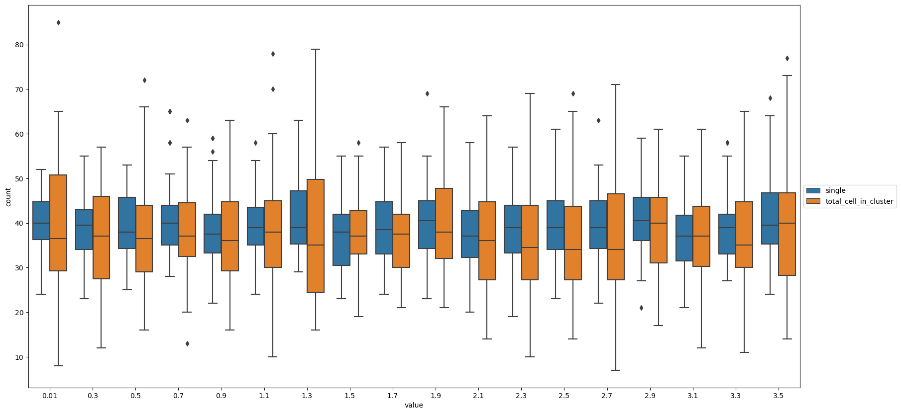

The analysis shows that the parameter has little impact on the separation of clusters and single cells.

* *cell_ecm_repulsion*

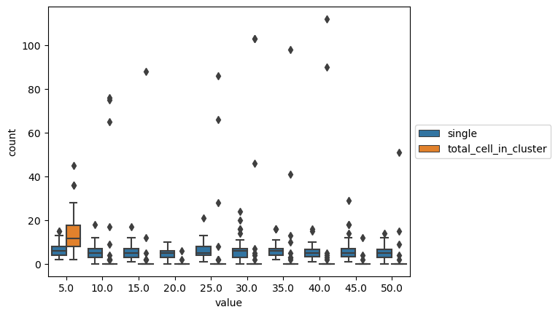

With values higher than 5, it is difficult to see cells in clusters. This is due to the fact that, in these conditions, there are very few cells that touch the ECM and thus, that can become mesenchymal.